User Guide

1. How to start up application
2. The Menu
3. How to add a new car to the application (Check-in)
4. How to find a car parked in car park
5. How to remove a car from the application (Check-out)
6. How to show a list of all cars in car park currently
7. How to exit application

How to start application:

Firstly to open your new application you must insert the desk containing the application, then you will be given this pop up screen:

From here please select the 'Car Park Application'

This will then show you the menu where will then work from, shown below.

The Menu:

This is the top menu, this is where you can view all the tasks that this application can do. To then move onto another task you must enter a number between 1 and 5.

Each number corresponds to a task that can be completed by this application. The corresponding number is shown to the left of the task that it will complete.

This is shown below.

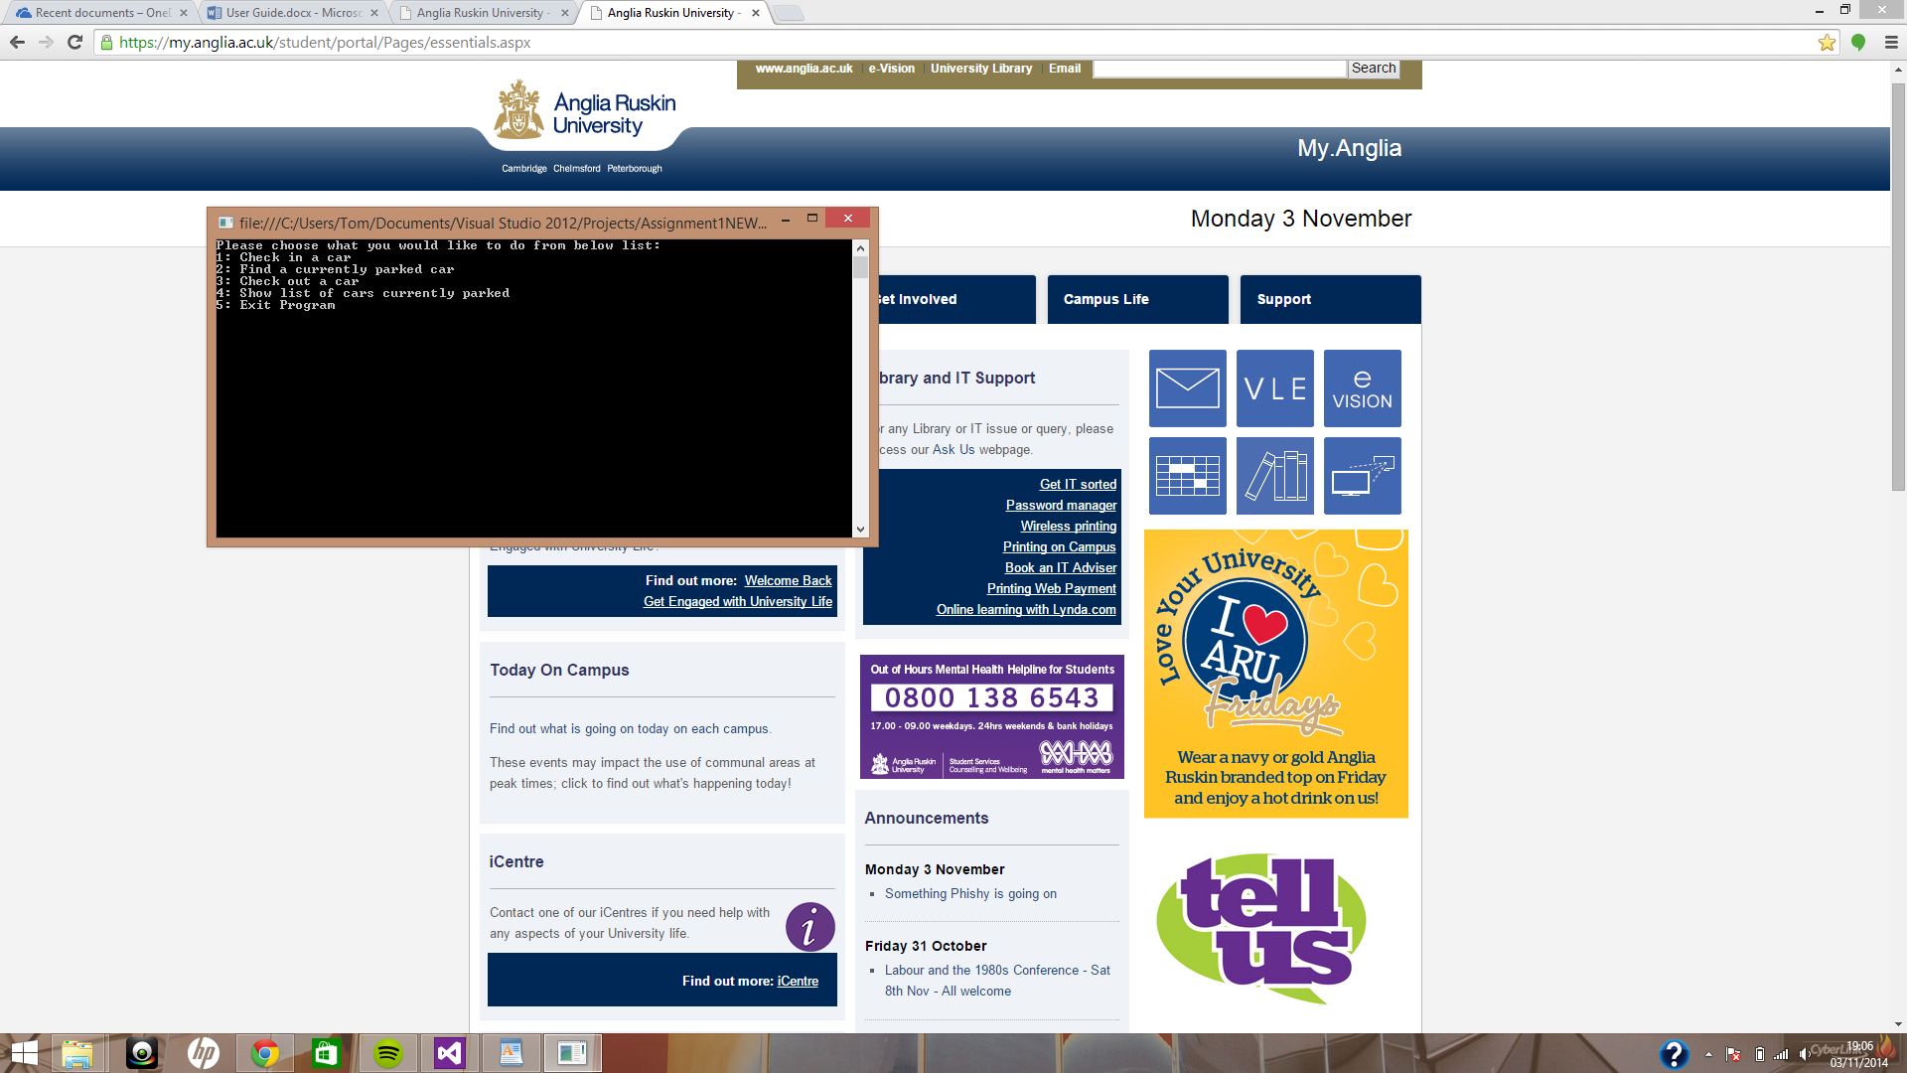

How to add a new car to the application (Check-in):

The first thing you'll want to do when you open the application is to check-in a car to the car park. To do this all you need to do is press '1' when the top menu is shown.

This will then ask you for the customer's name then hit 'enter'

After you have pressed enter you will then be prompted to add a number plate. When you have done this, again, hit enter.

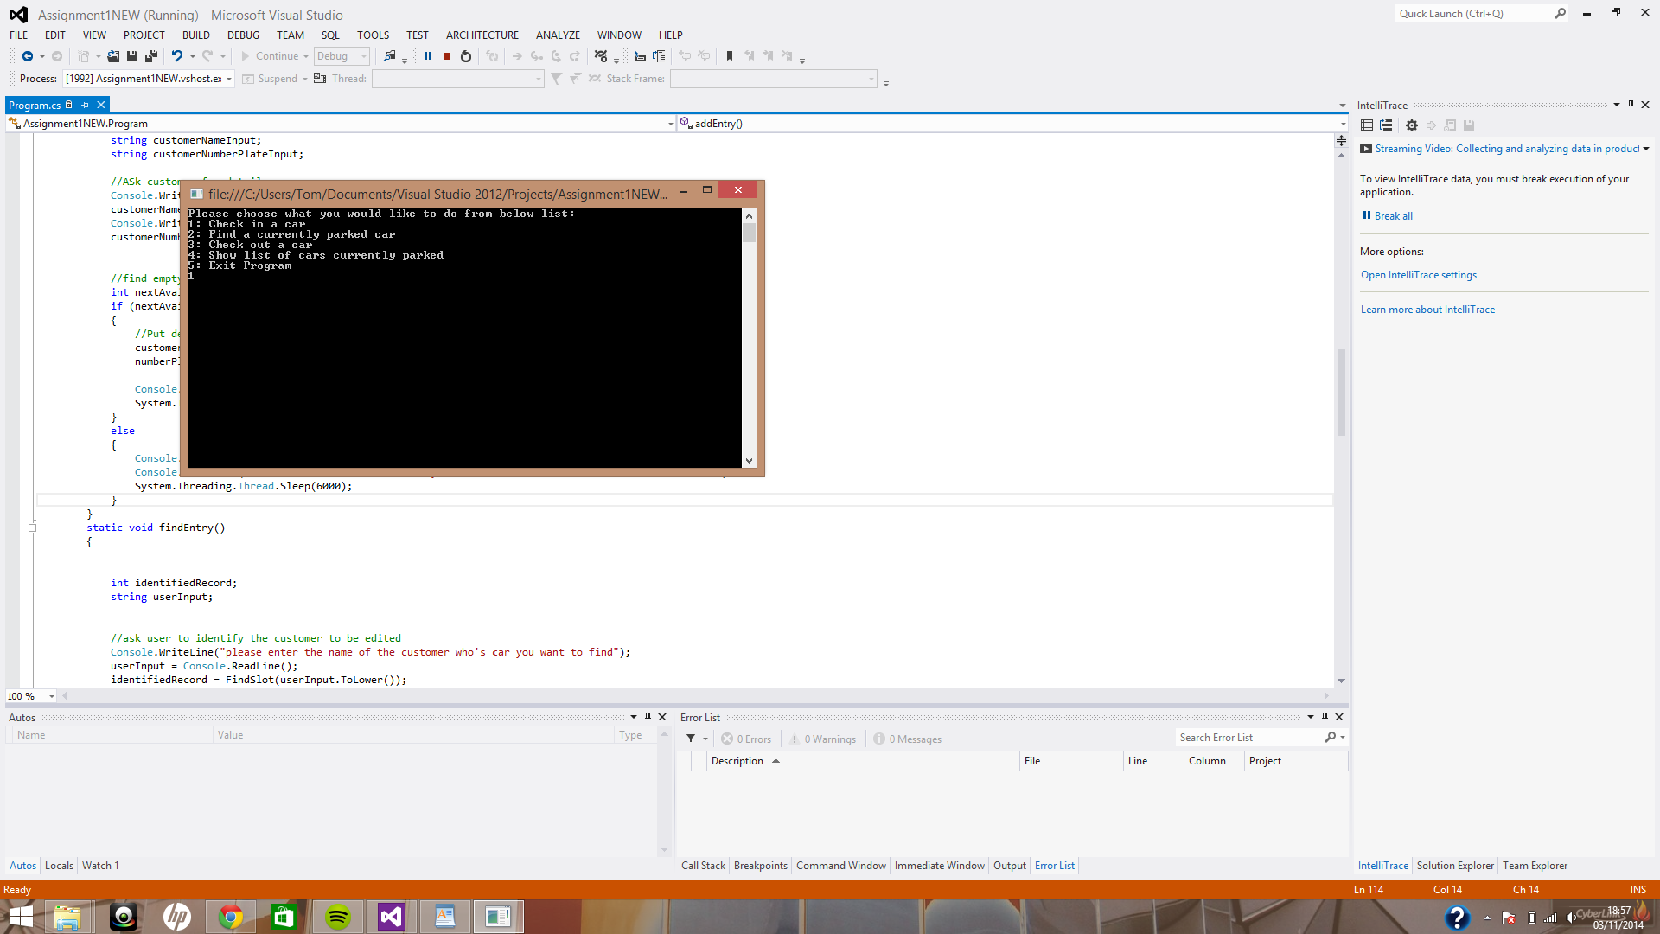Shown below:

After pressing 'enter' for the second time you will then be told that the car has been parked, or, if all spaces are taken up, you will be told that there are no available spaces and to tell the customer to wait until one becomes available.

Both outcomes shown below:

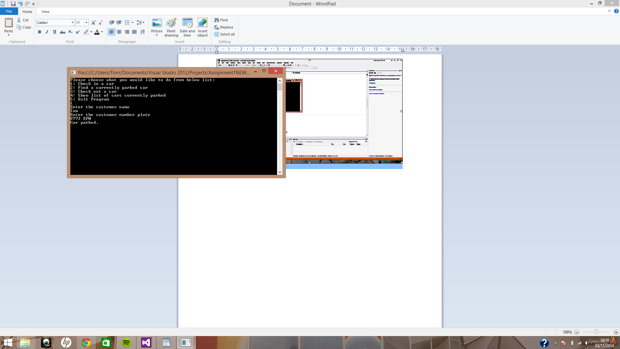

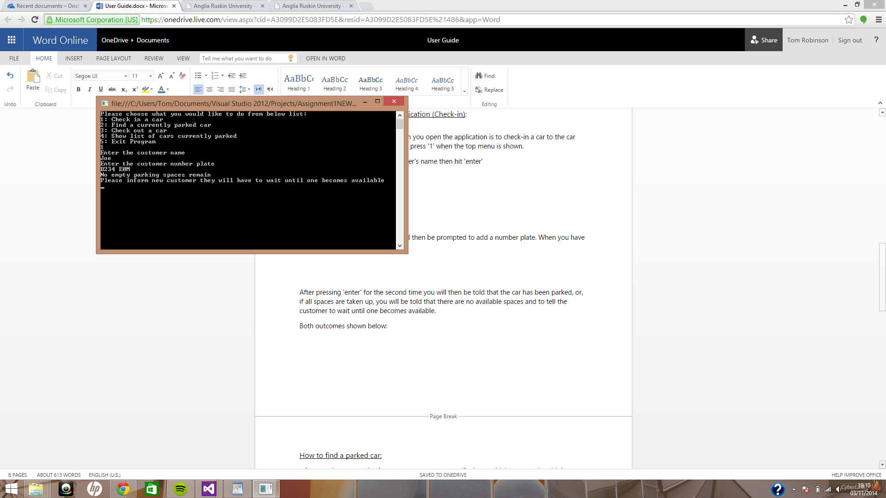

How to find a parked car:

After you have stored a few cars you may want to find out which cars are in which spaces, to do this you need to press '2' from the top menu and it will bring you to the screen shown below. From here you will be prompted to enter the customer's name.

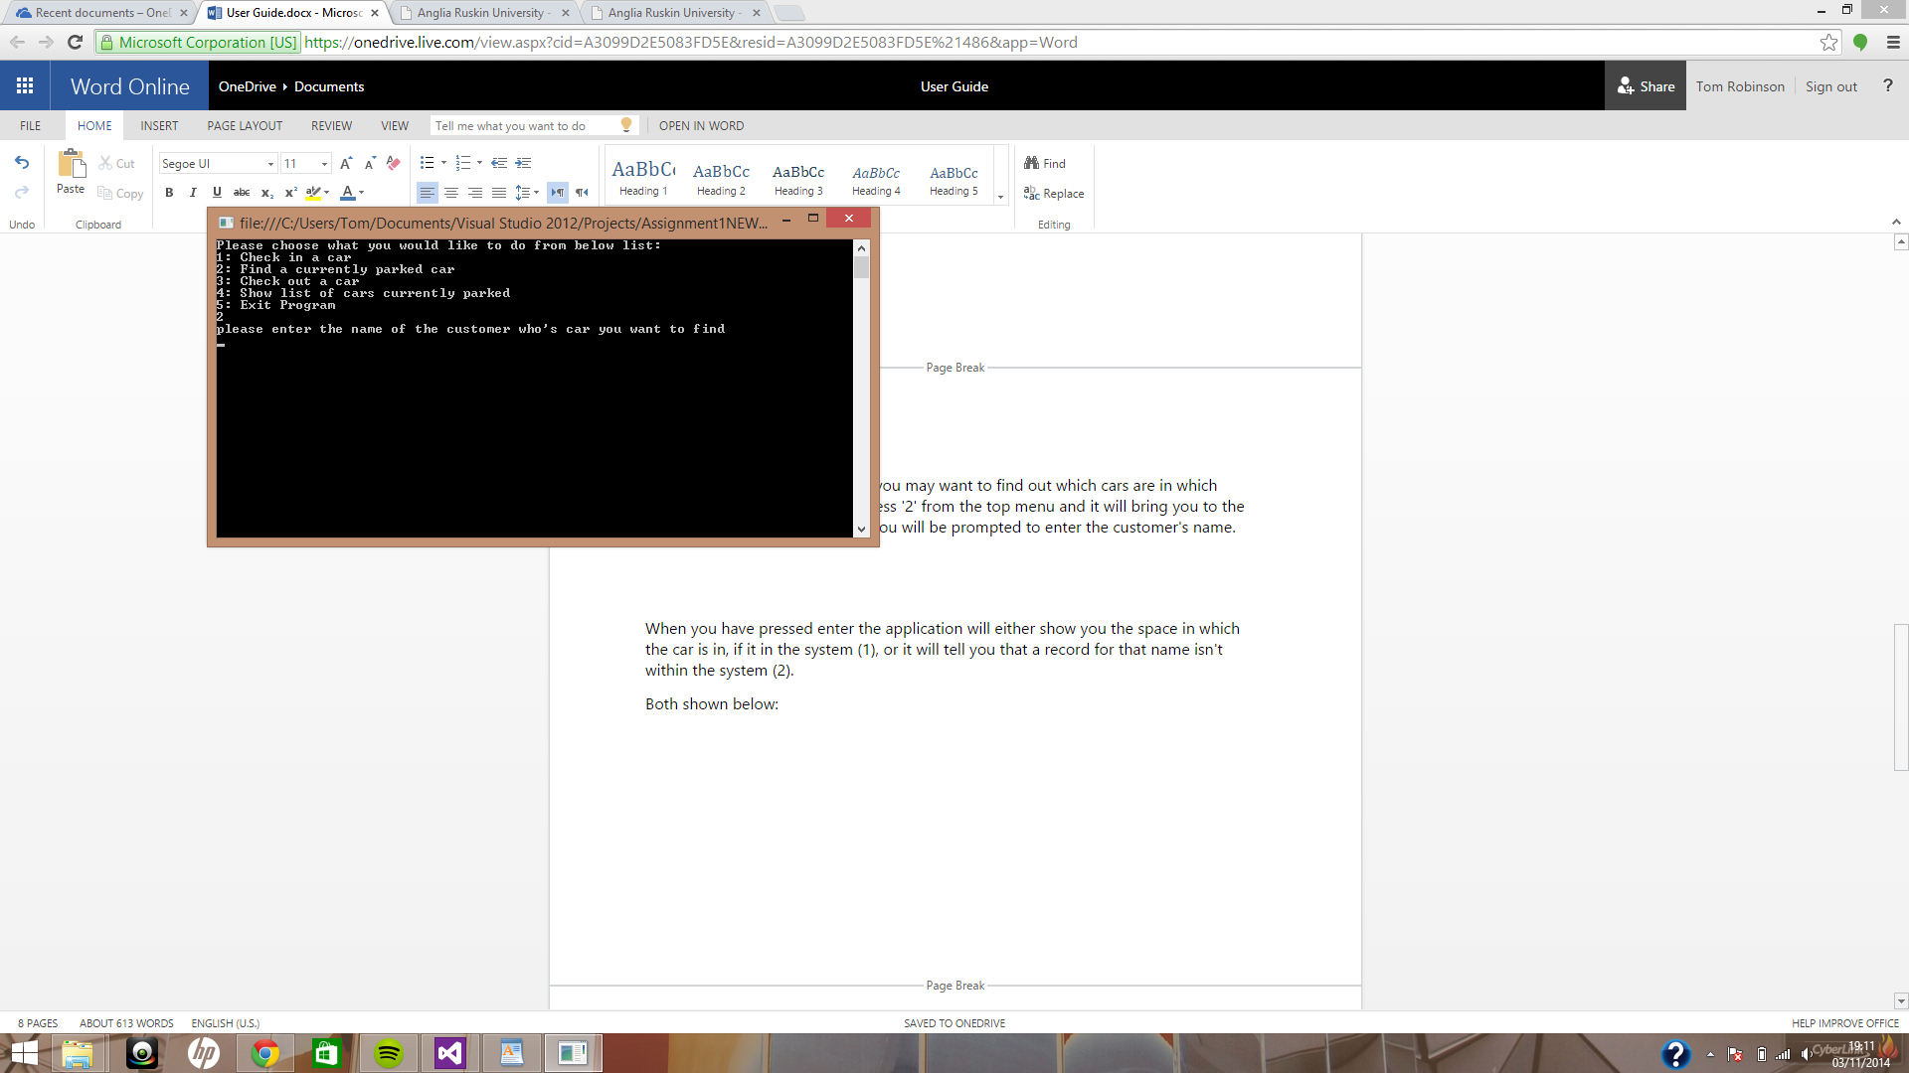

When you have pressed enter the application will either show you the space in which the car is in, if it in the system (1), or it will tell you that a record for that name isn't within the system (2).

Both shown below:

1)

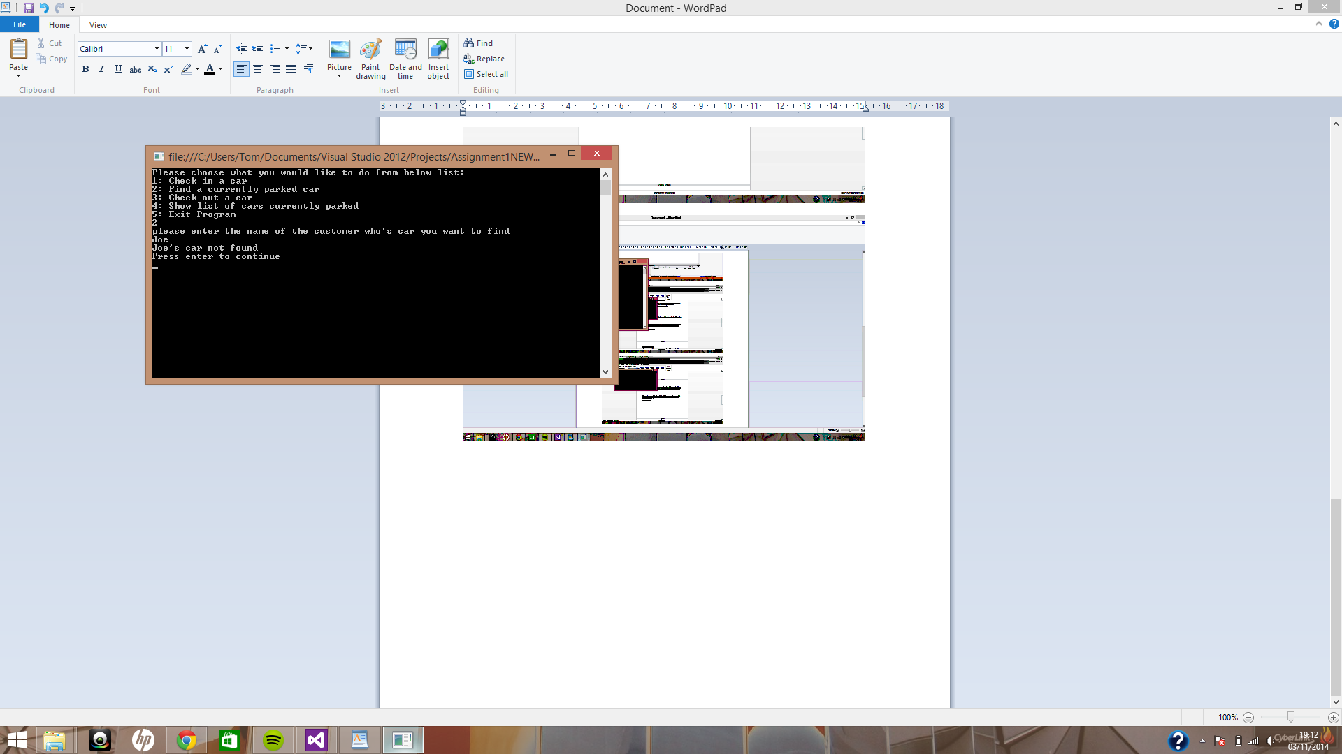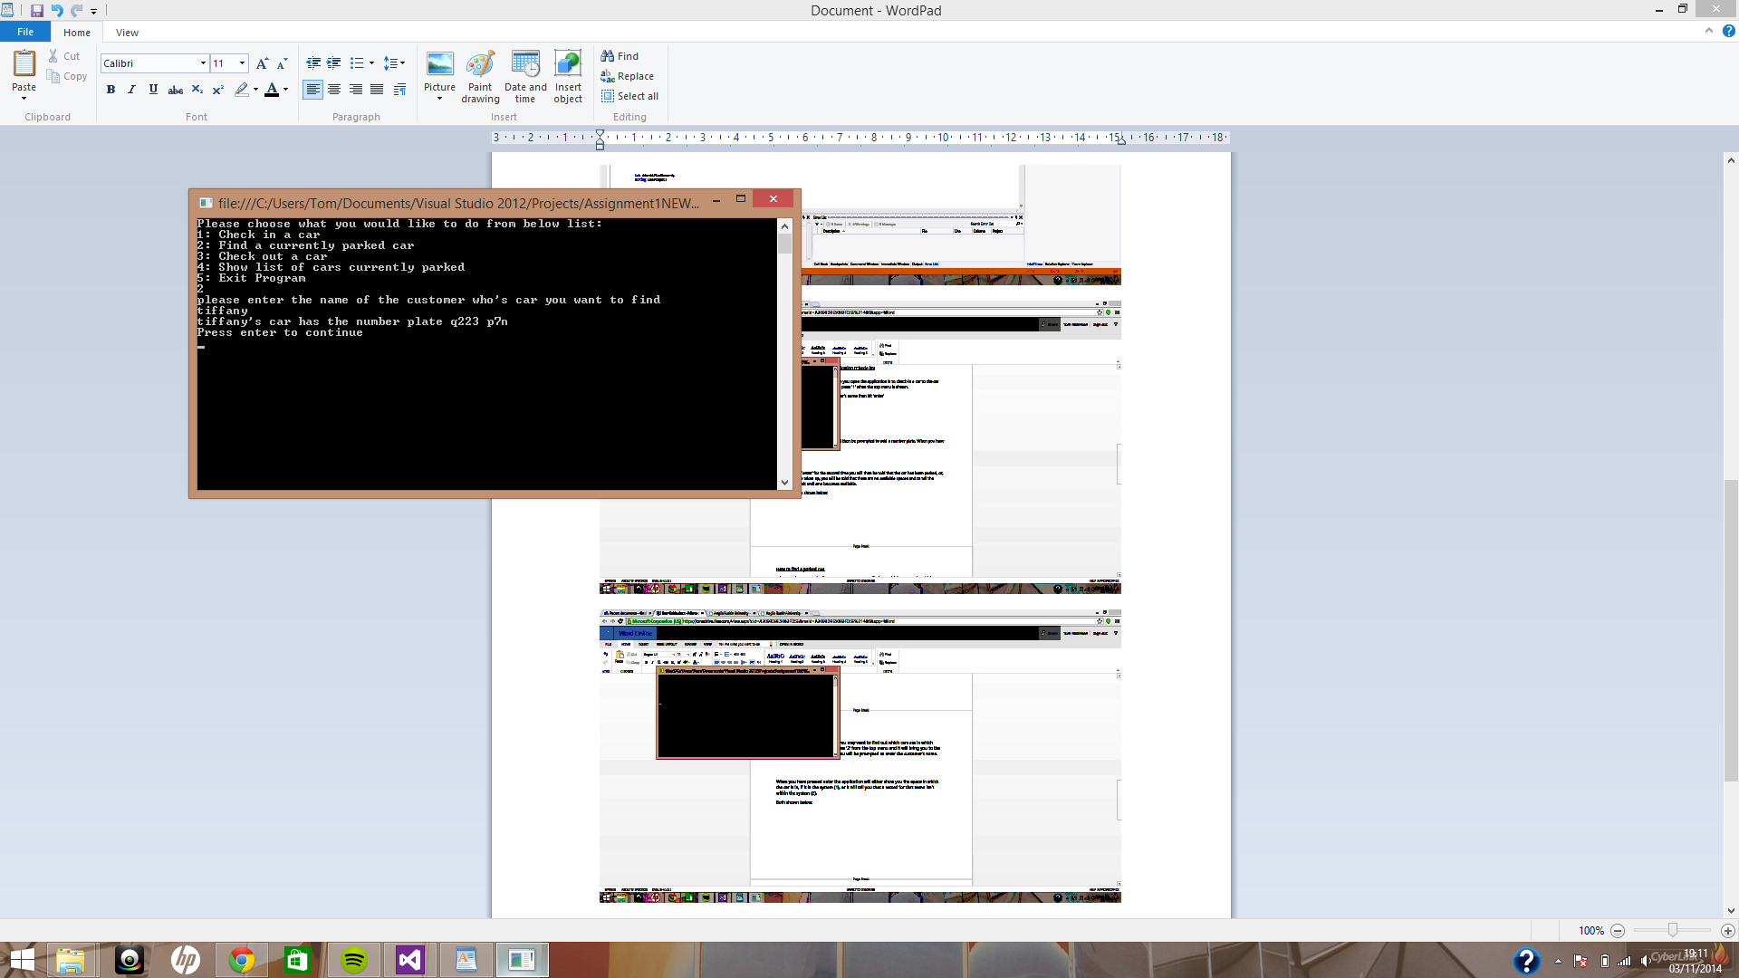

2)

How to remove a car from the application (Check out):

To check-out a car you must press '3' from the top menu, you will then be taken to the screen below. Here you will be asked to enter the name of the customer that will be leaving the car park.

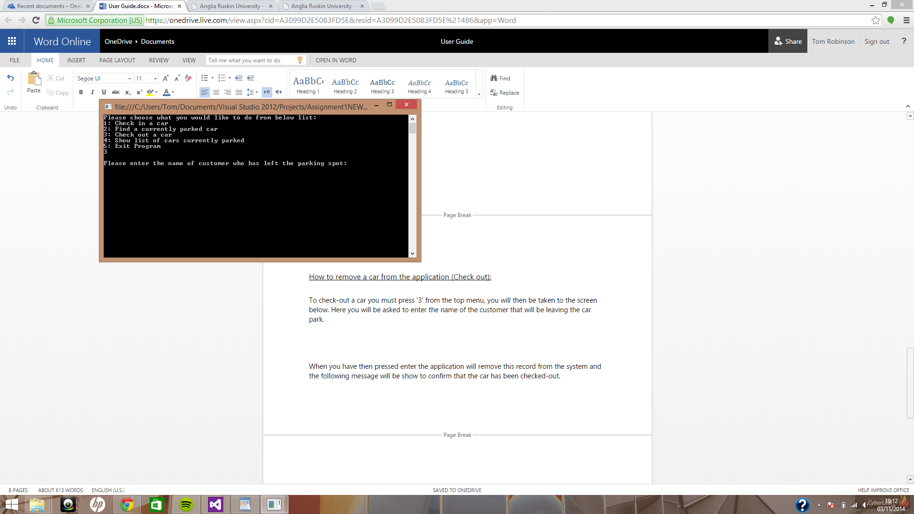

When you have then pressed enter the application will remove this record from the system and the following message will be show to confirm that the car has been checked-out.

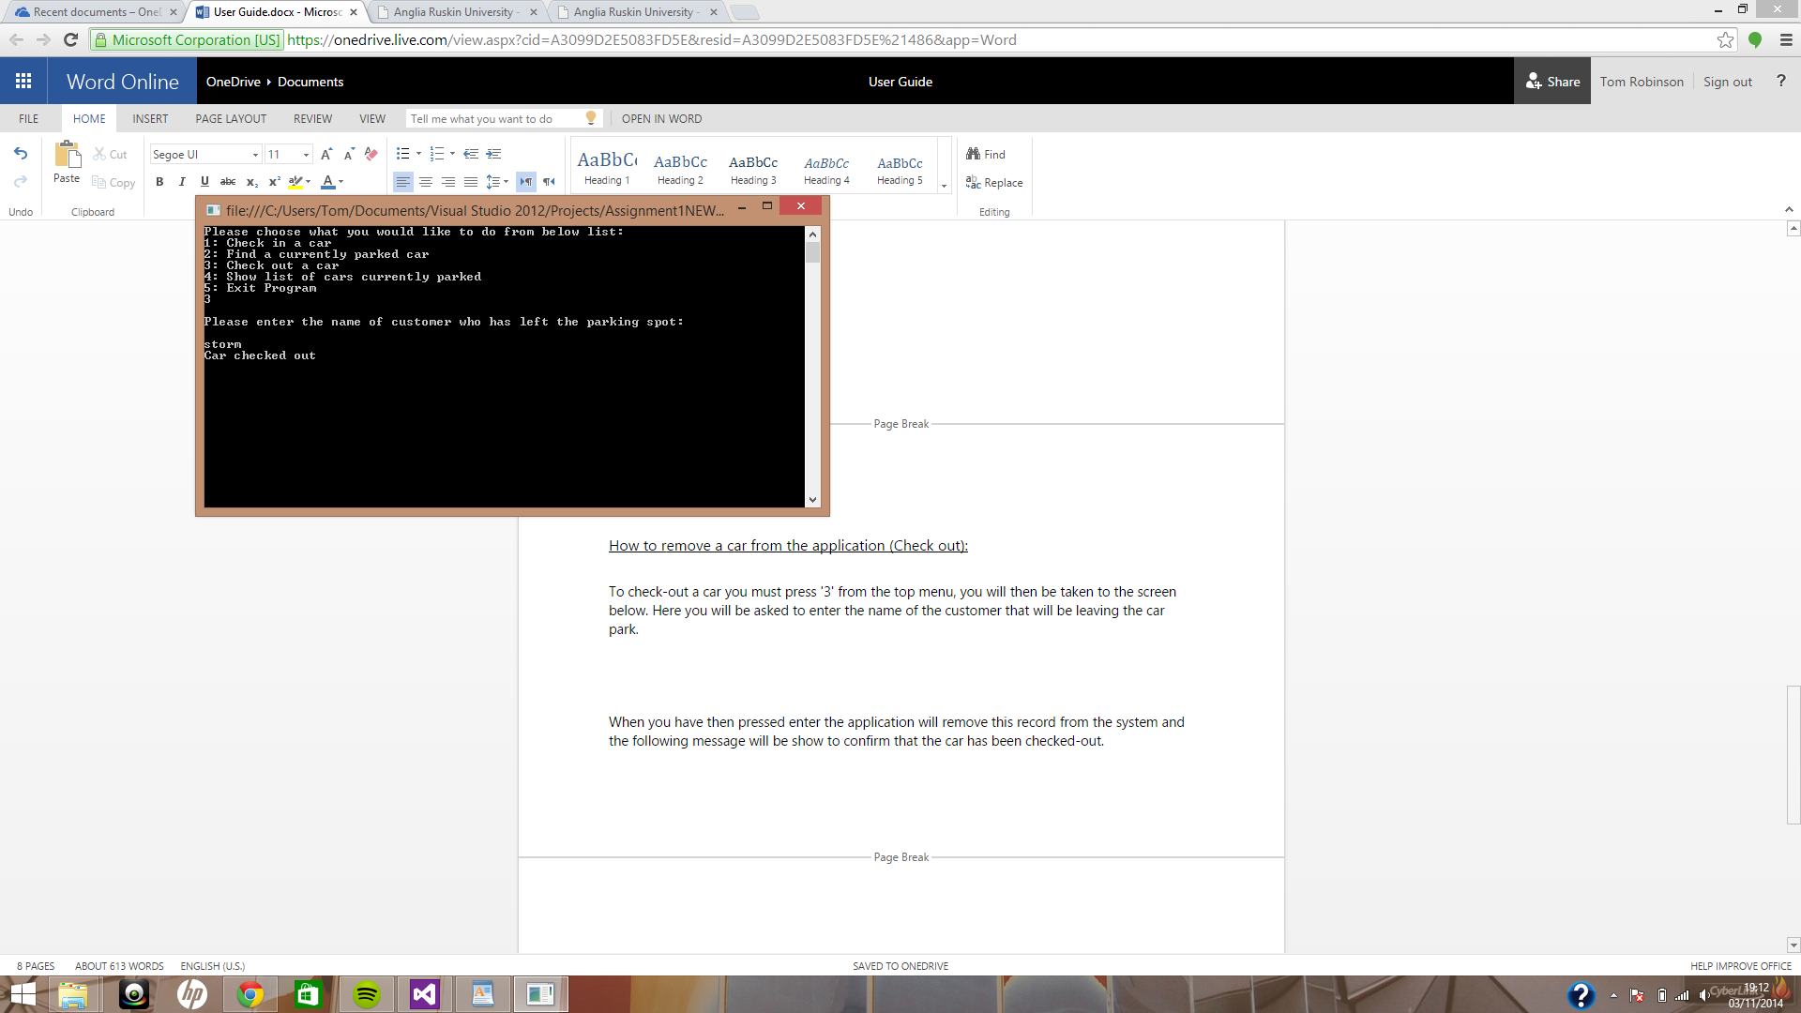

How to show a list of all cars in car park currently:

To see a list of all the cars that are parked currently press '4' from the top menu, you will then be taken to a screen where you will be able to see the each of the customers and their number plates one by one, pressing enter after each is shown to show next entry.

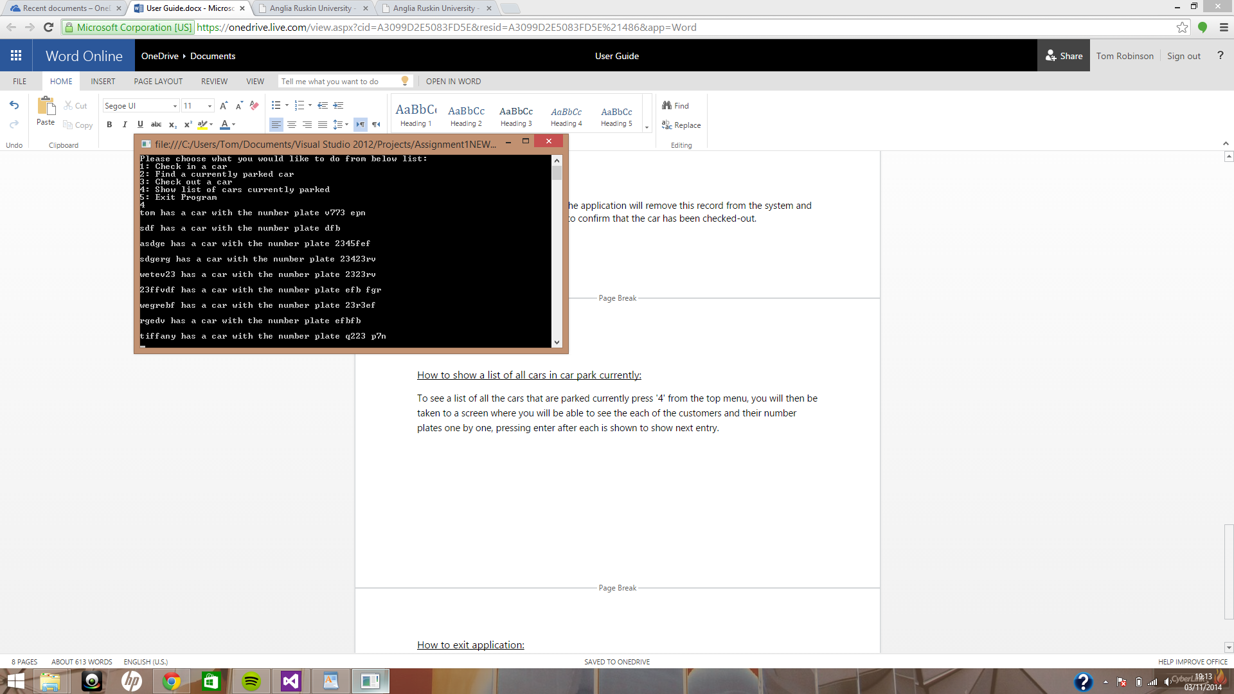

How to exit application:

When you are done with this session and want to exit the application, from the top menu press '5' this will then produce a blank line and then the application will close.

